

YEAR 12 GENERAL HUMAN BIOLOGY

Task 3: Skeletal and Muscular Systems Test

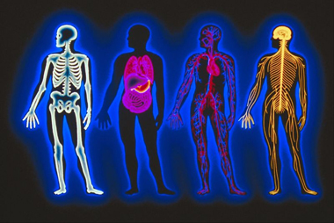

-DO NOT MARK THIS BOOKLET-

Multiple Choice: 15 marks

Short Answer: 30 marks

**TOTAL 45 MARKS**

**Section A: Multiple Choice (15 Marks)**

Answer all questions by placing and X through the most correct answer on the multiple choice answer sheet.

1. The vertebral column, rib cage and skull form the:

(a) axial skeleton.

(b) pectoral girdle.

(c) appendicular skeleton.

(d) pelvic girdle.

1. The type of joint illustrated by the head on the spinal column [atlas] is a:

(a) ball and socket.

(b) hinge.

(c) pivot.

(d) partially moveable.

1. The bones of the lower limb do **NOT** include the:

(a) metatarsals.

(b) tibia.

(c) scapula.

1. fibula.

Diagram below refers to questions 5 and 6



1. Which of the above is a hinge joint ?

(a) A.

(b) B.

(c) C.

(d) D.

1. Which one of the following pairs of movements is possible at the joint named **E**?

(a) flexion and abduction.

(b) extension and rotation.

(c) extension and adduction.

(d) flexion and extension.

1. The shaft of a long bone is called the:

(a) epiphysis.

(b) diaphysis.

(c) periosteum.

(d) central column.

1. The function of synovial fluid is to:

(a) maintain strong ligaments.

(b) allow friction-free movement in joints.

(c) provide added strength to joints.

1. lubricate the tendons.
2. The major mineral elements deposited in bone are:

(a) magnesium and calcium.

(b) phosphorous and calcium.

(c) phosphorous and magnesium.

1. phosphorous, magnesium and calcium
2. Contraction of which one of the following muscles will cause a straightened arm to bend ?

(a) Triceps.

(b) Extensors.

(c) Biceps.

(d) Quadriceps.

The next two questions refer to the following diagram

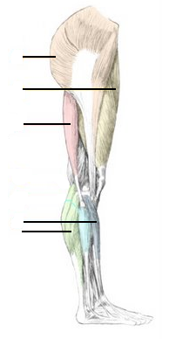

**A**

**B**

**C**

**D**

**E**

10). Two antagonistic muscles are:

(a) C and D

(b) A and C

(c) B and E

(d) B and C

11). The muscles which would raise the toes off the ground would be:

(a) B

(b) C

(c) D

(d) E

Refer to the diagram opposite

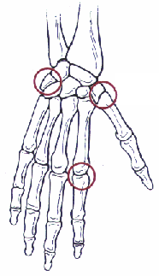

**A**

12). The joint labelled A

(a) Saddle joint

(b) Hinge Joint

(c) Condyloid

(d) Gliding joint

13). Place the words in the correct order to show the muscle structure from large structures to smallest structures.

(a) actin, myosin, myofibrils, muscle fibres, skeletal muscle

(b) skeletal muscle, muscle fibres, myofibrils, actin, myosin

(c) myofibrils, actin, myosin, muscle fibres, skeletal muscle

(d) skeletal muscle, myofibrils, muscle fibres, actin, myosin

14). Which of the following pairings is correct?

(a) Hip - Ball and socket.

(b) Thumb - Pivot.

(c) Elbow - Gliding.

(d) Wrist - Hinge.

15). In the following diagram the movement of the left lower limb which has occurred in moving from position **A** to position **B** include:

**A** **B**

a) flexion at the hip and flexion at the knee

b) flexion at the hip and extension at the knee

c) extension at the hip and flexion at the knee

d) extension at the hip and extension at the knee

**PART B: Short Answer Section (30 marks)**

**Question 16**

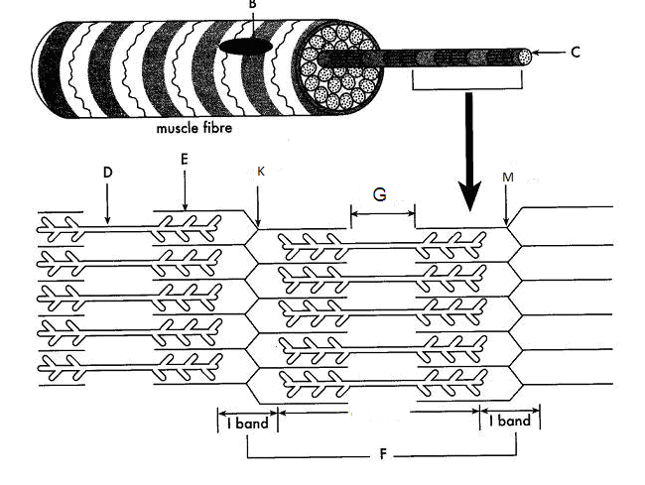

Part (a) of the question refers to the diagram above.

(a) The diagram represents the sliding filament model of muscle contraction. A sarcomere in a skeletal muscle is shown in the relaxed position.

(i) Identify the proteins labelled as D and E in the diagram. (2 marks)

D ________________________________________________

E _________________________________________________

(ii) In the box below, accurately draw the same sarcomere as it would appear when the muscle is contracted. (2 marks)

(b) Apart from skeletal muscle, there are two other muscle types in the human body.

Name one other muscle type and state one way in which the structure of this type of muscle differs from skeletal muscle. (2 marks)

________________________________________________________________________________________________________________________________________________________________________________________________________________________________________________________________________________________________________________________________________________________________________________________________________________________________________________

**Total: 6 marks**

**Question 17** refers to the diagram below

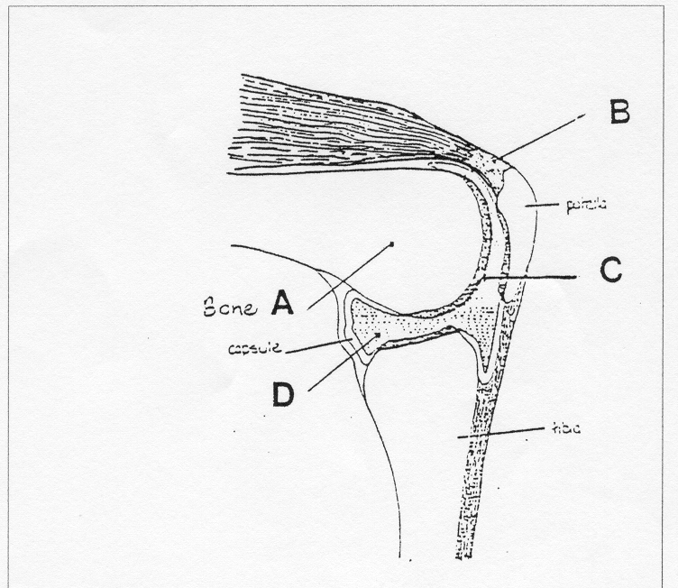

1. Label the structures A, B, C and D in the spaces provided below.

#### A ____________________________ C_____________________________

#### B ____________________________ D_____________________________

(4 marks)

b. Describe the function of structure C

________________________________________________________________________________________________________________________________________________________________________________________________________________________

(1 mark)

b. The type of joint illustrated above is a synovial hinge joint. Name two other types of synovial joints and give an example of where they are found.

i)_______________________________________________________________

ii)_______________________________________________________________

(2 marks)

c**.** Name and Describe the three categories of joints found in the body (6 marks)

|  |  |
| --- | --- |
| **Joint** | **Description** |
|  |  |
|  |  |
|  |  |

**Total: 13 marks**

**Question 18.**

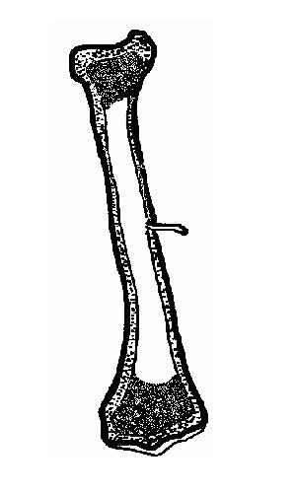

A

B

Below is the structure of a long bone

a) Label the following components (2 marks)

A. ____________________________________

B. ____________________________________

b) Describe one way in which the structure of the long bone is suited to the following functions of the skeleton (4 marks)

|  |  |
| --- | --- |
| **Function** | **Description** |
| Support |  |
| Movement |  |
| Storage |  |
| Blood cell production |  |

**Total:6 marks**

**Question 19**

You are watching a game of netball and one of the players falls to the ground holding her knee.

1. List three symptoms she would display if she had torn her Anterior Cruciate Ligament

______________________________________________________________________________________________________________________________________________________________________________________________________________________________________________________________________________________________________________________________________________________________________________________________________________________________

(3 marks)

1. How would a doctor confirm this diagnosis?

______________________________________________________________________________________________________________________________________________________________________________________________________________________________________________________________________________________________________________________________________________________________________________________________________________________________

(2 marks)



**YEAR 12 GTHBY HUMAN BIOLOGY**

Task 3: Skeletal and Muscular Systems Test

SCORES:

MC: /15

SA: /30

TOTAL: /45

_______ %

**NAME:_____________________________**

**TEACHER:__________________________**

**DATE:______________________________**

**Section A: Multiple choice (15 Marks)**

Answer all questions by circling the most correct answer on the multiple choice answer sheet.

1. a b c d 13. a b c d

2. a b c d 14. a b c d

3. a b c d 15. a b c d

4. a b c d

5. a b c d

6. a b c d

7. a b c d

8. a b c d

9. a b c d

10. a b c d

11. a b c d

12. a b c d